# INDIA’S AGRICULTURAL CROP PRODUCTION

# PROJECT DOCUMENTATION

## Step-1 : Data visualization

Activity.1.1

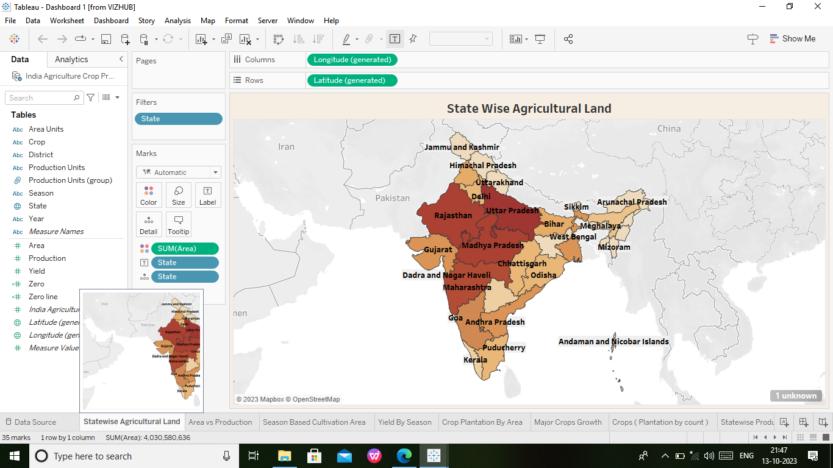

* First we create the data visualization.
* We create the State wise Agricultural Land on the first sheet.
* Enter the table values and created the sheet.

Activity.1.2.

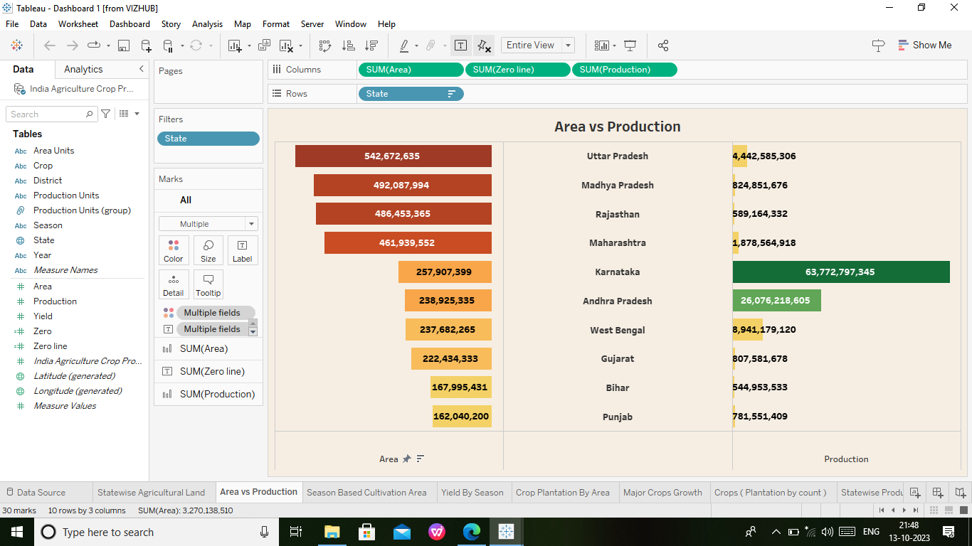

* Next Sheet we will open and create the Area vs production on the sheet.
* Again enter the table values and created the sheet.

Activity.1.3.

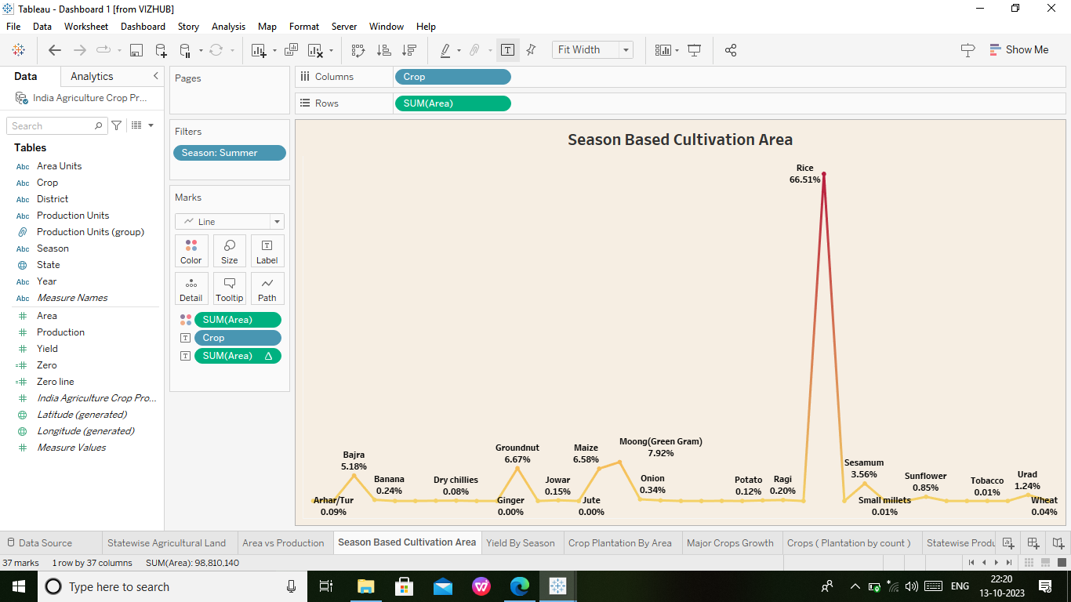

* We take the next sheet and create the Season Based cultivation Area on the sheet.
* Again enter the table values are in filters,colour,label and so on.
* Hence Created the sheet.

Activity.1.4.

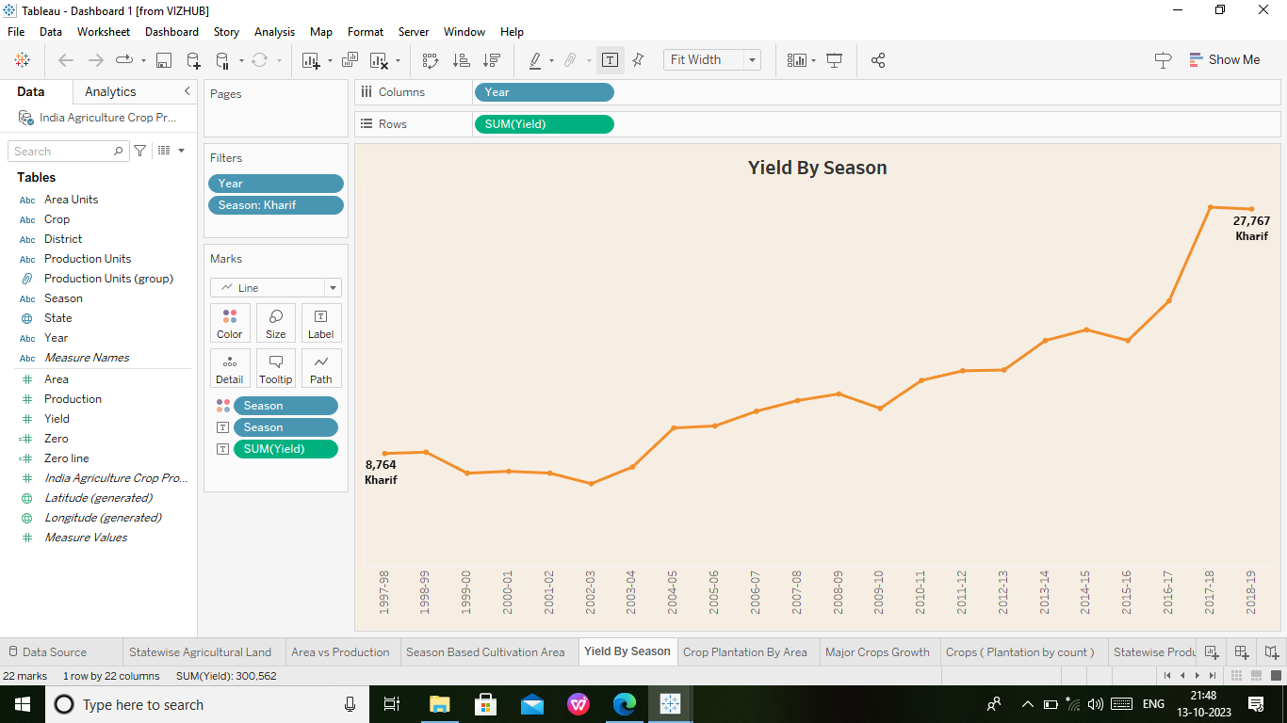

* Take the next sheet and the Yield by Season create on the sheet.
* Enter the table values and created the sheet.

Activity.1.5.

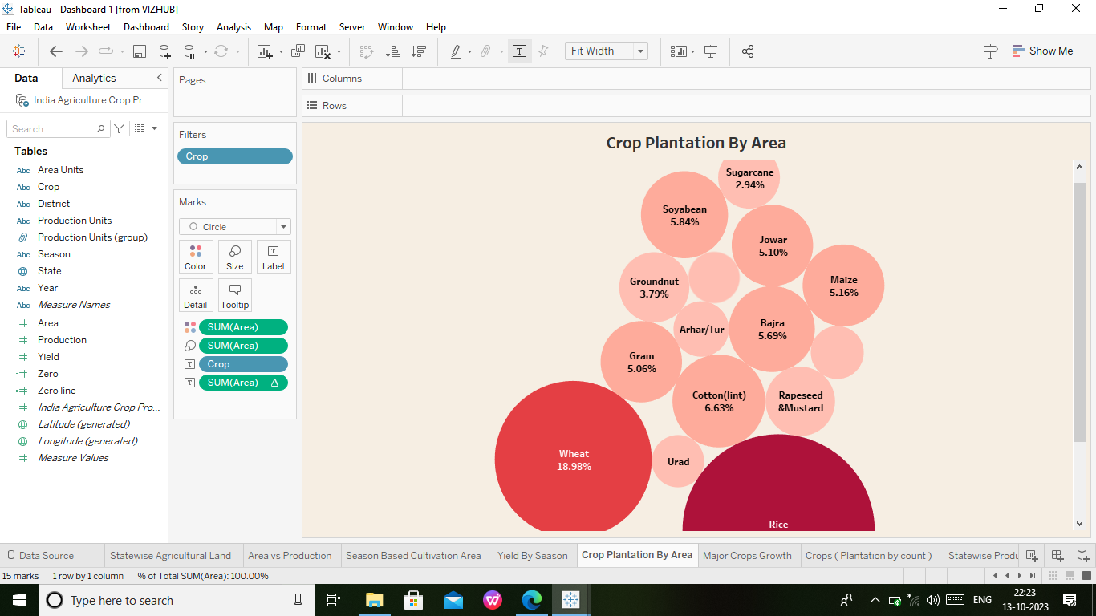

* Open the next sheet and the Crop plantation by area create on the sheet.
* The table values are enter in the sheet.
* Created the sheet.

Activity.1.6.

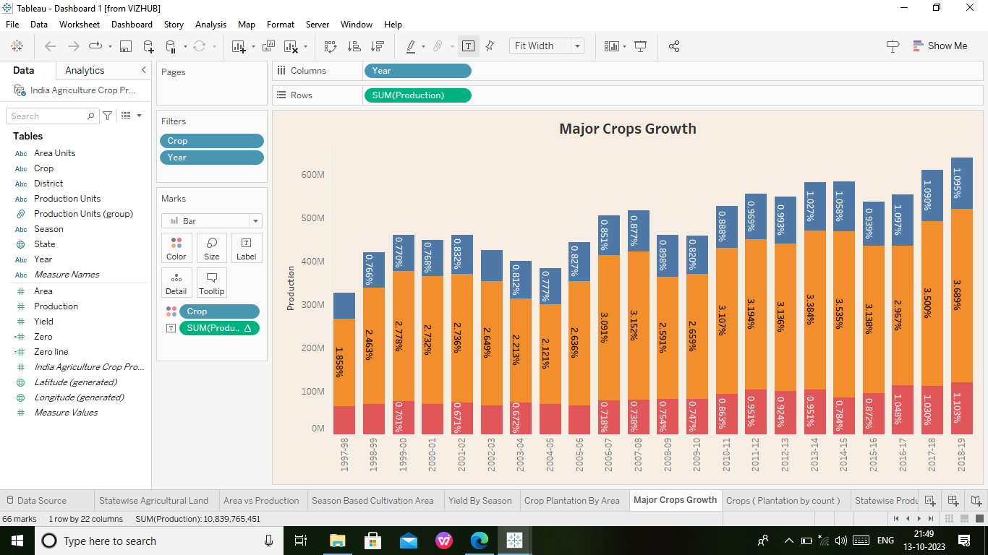

* We take the next sheet and The Major crops Growth create on the sheet.
* The table values are enter in the sheet.

Activity.1.7.

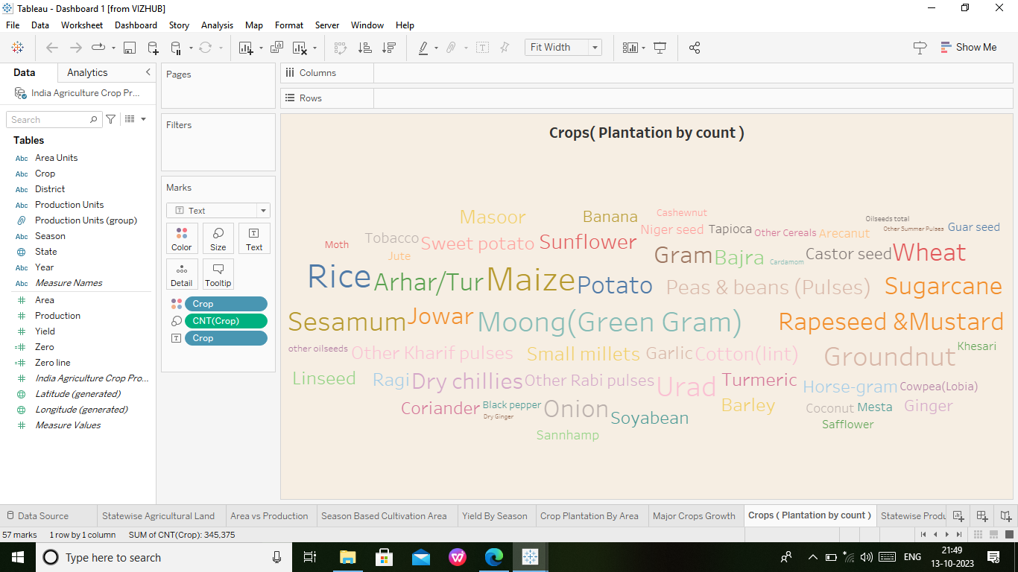

* Again take the next sheet and The Crops ( Plantation by count) create on the sheet.
* The table values are enter in the sheet.

Activity.1.8.

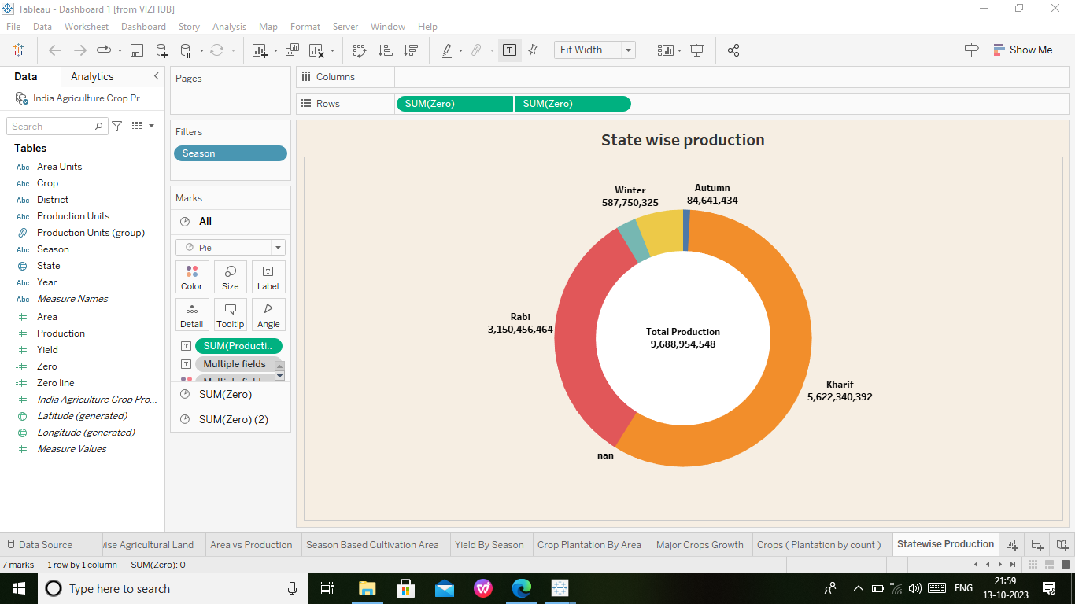

* Open the next sheet and The State wise production create on the sheet.
* The table values are apply in the sheet.

Activity.1.9.

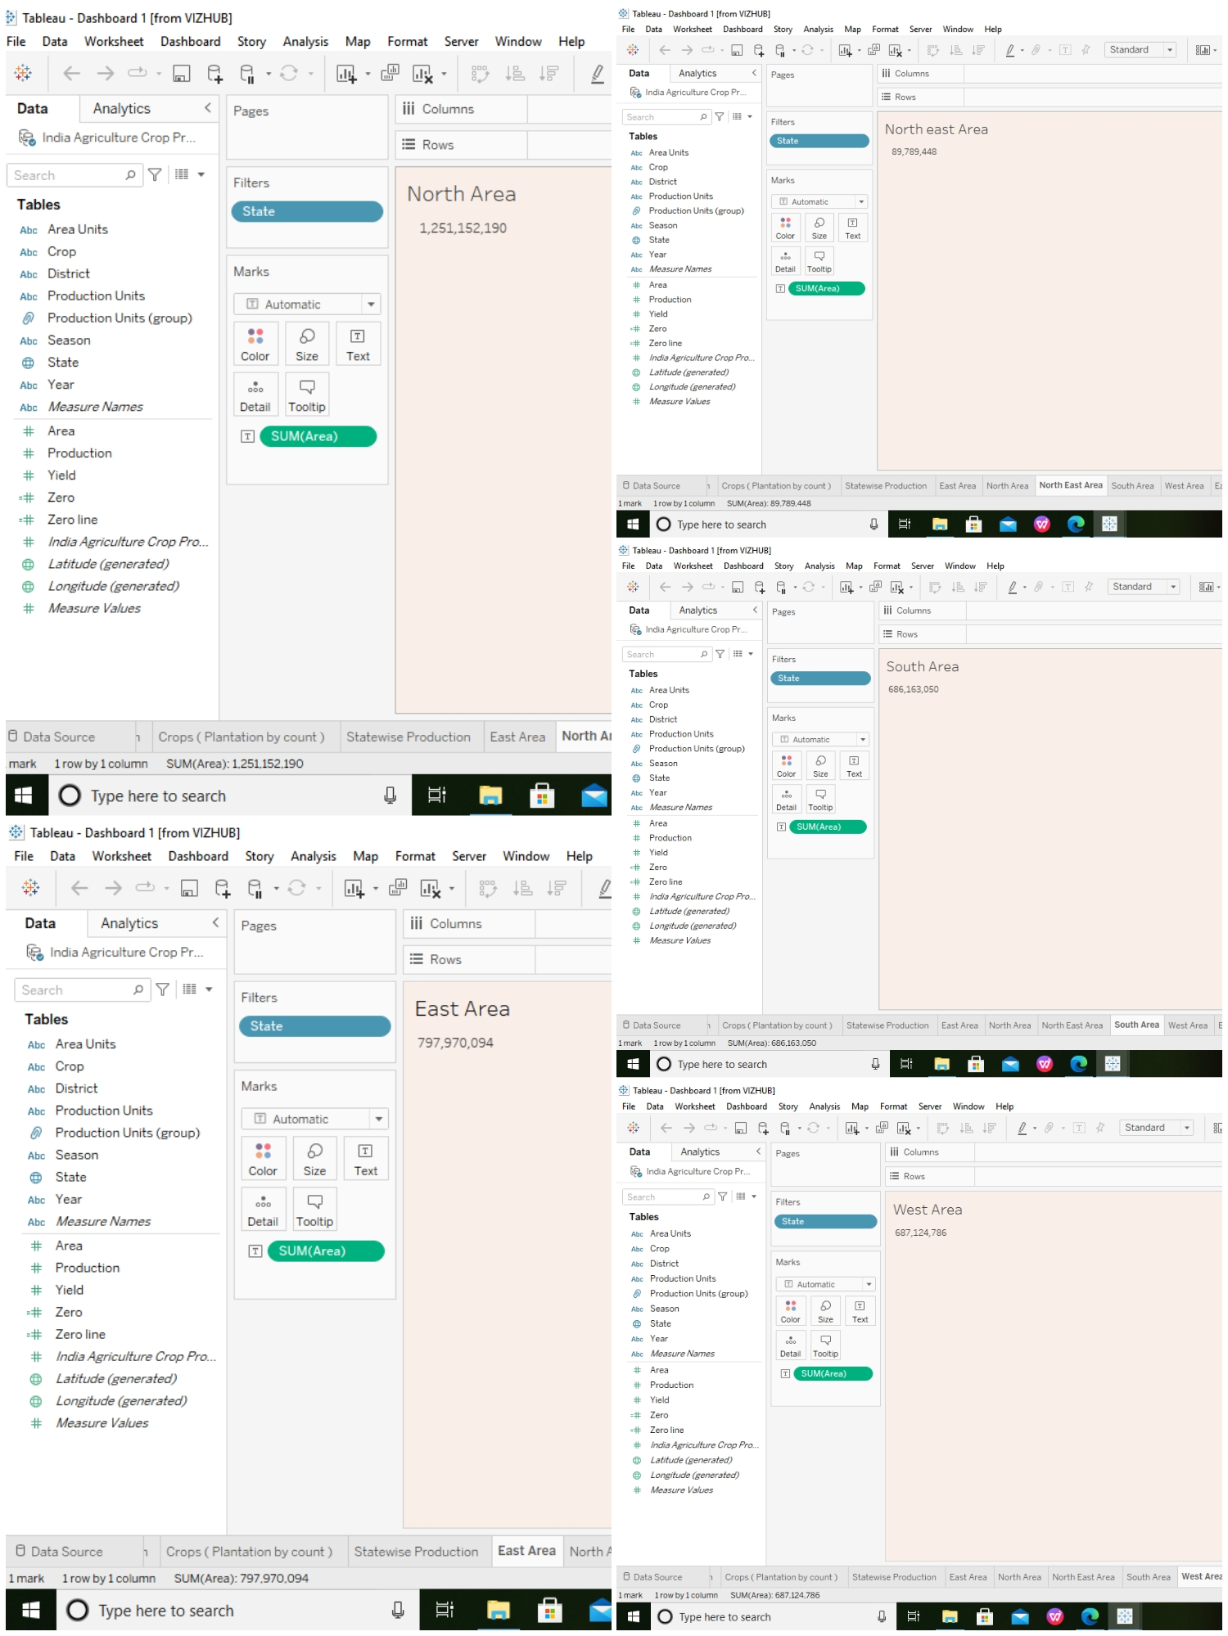

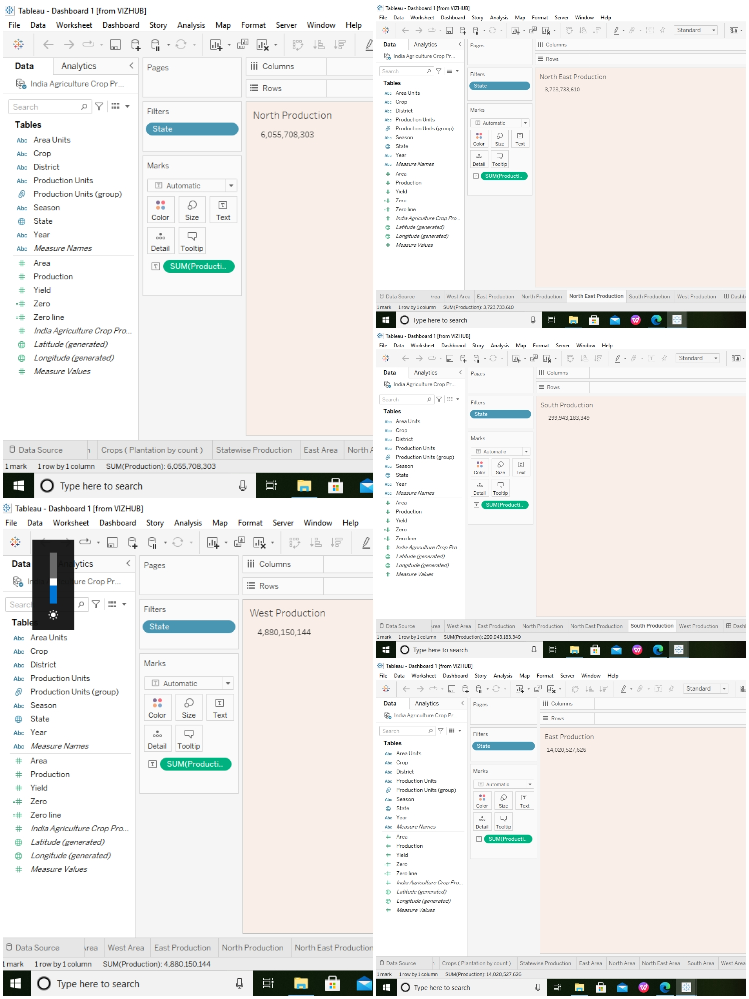

* Next take the some sheets and The Area create on the sheet by the directions.
* At the same process the Production create on the sheet by the directions.

## Step-2 : Dashboard

Dashboard-1:

## Screenshot (21)

Dashboard-2:

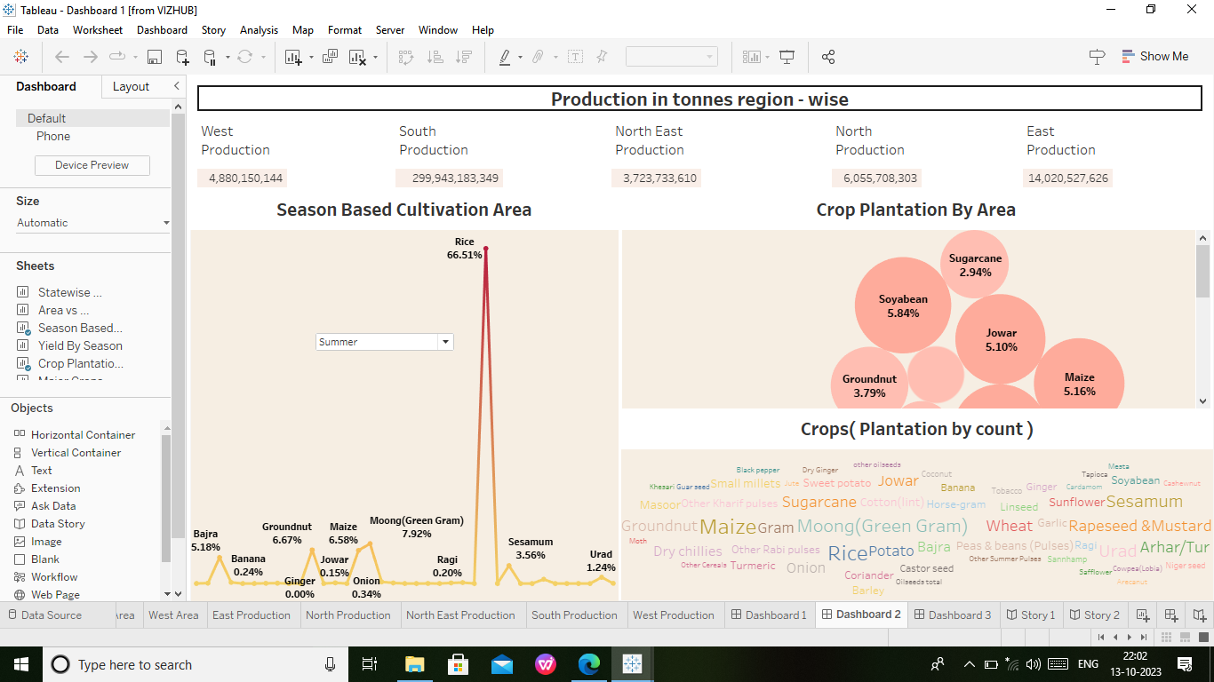

Dashboard-3:

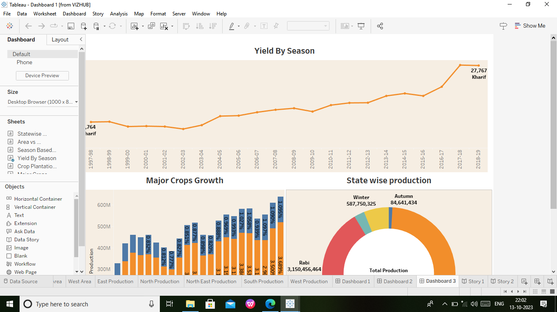

* We have created dashbord using data visualization.

## Step-3 : Story

Story-1:

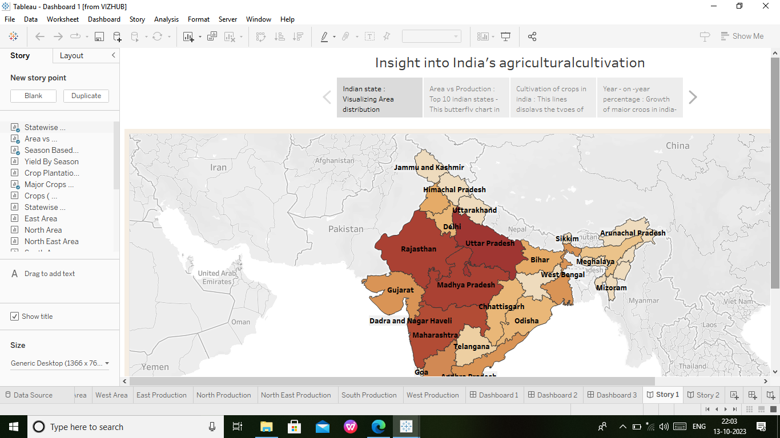

Story-2:

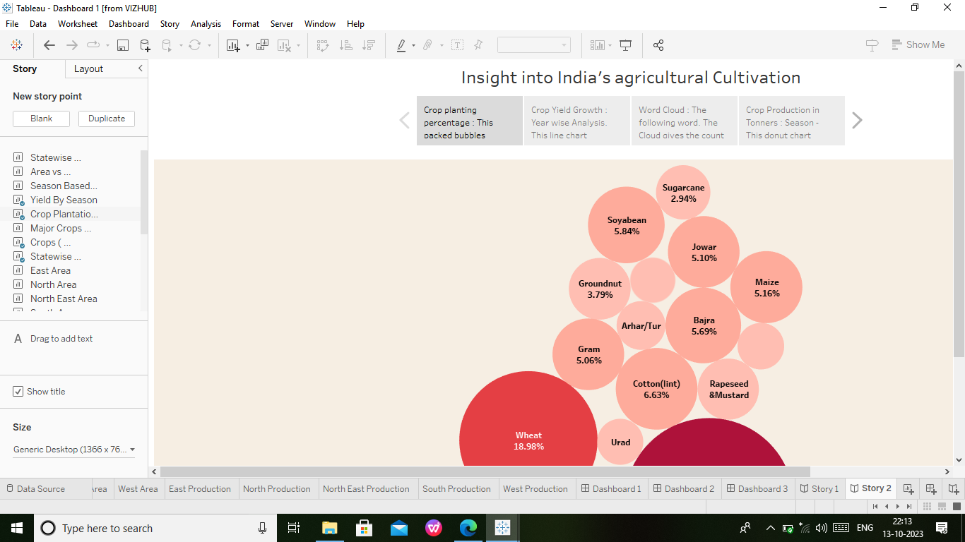

* We have created story using with dashboard.

Finally we have completed the step by step project development process.

s